# Lab: Arrays

## Sum First and Last Array Elements

Write a function that receives an **array of strings** and prints the sum of **first** and **last** element in that array.

### Examples

|  |  |
| --- | --- |
| **Input** | **Output** |
| ['20', '30', '40'] | 60 |
| ['10', '17', '22', '33'] | 43 |
| ['11', '58', '69'] | 80 |

### Hints

* Use the Number() function

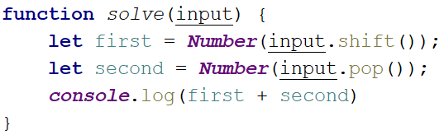

## Day of Week

Write a program which receives a **number** and prints the corresponding **name** of the **day** of week.

If the number is **NOT** a valid day, print 'Invalid day!'.

### Examples

|  |  |
| --- | --- |
| **Input** | **Output** |
| 3 | Wednesday |
| 6 | Saturday |
| 11 | Invalid day! |

### Hints

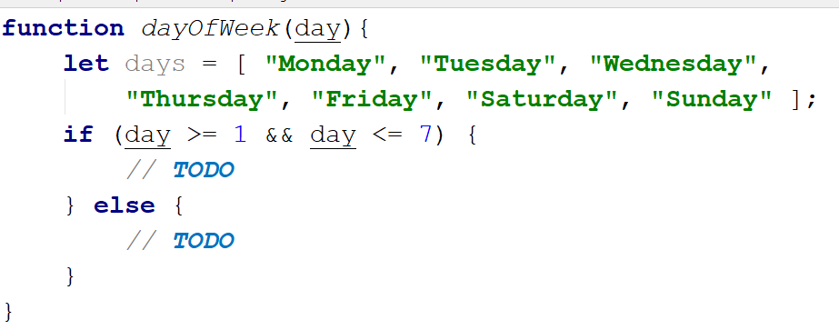

unction solve(array,day){  
  
 if(day>=1 && day<=6){  
 ***console***.log(array[day]);  
 }else{  
 ***console***.log(`Write from 1 to 7`);  
 }  
  
  
  
}solve(['Monday','Tuesday','Wednesday','Thursday','Friday','Saturday','Sunday'],2)

## Reverse an Array of Numbers

Write a program which receives a number n and an **array** of elements. Your task is to **create** a new array with n numbers, **reverse** it and print its elements on a single line, space separated.

### Examples

|  |  |
| --- | --- |
| **Input** | **Output** |
| 3, [10, 20, 30, 40, 50] | 30 20 10 |
| 4, [-1, 20, 99, 5] | 5 99 20 -1 |
| 2, [66, 43, 75, 89, 47] | 43 66 |

### Hints

* Use push() to add elements inside the new array

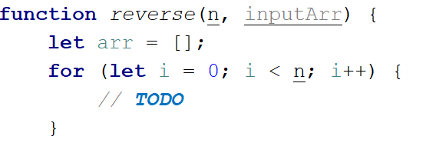

* Use **string interpolation** for the output

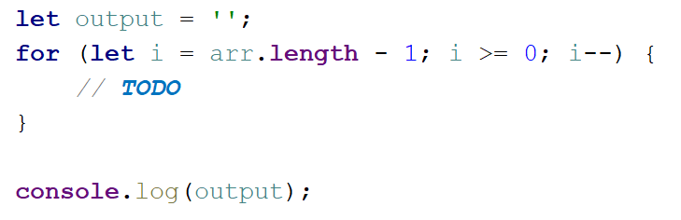

function solve(sliceNum,array){  
  
  
 let arr=array.splice(0,sliceNum);  
 ***console***.log(arr);  
  
 let result=arr.sort(sorted);  
  
 ***console***.log(result);  
  
 function sorted(a,b) {  
  
 return b-a;  
  
 }  
  
  
}solve(3, [10, 20, 30, 40, 50]);

## Reverse an Array of Strings

Write a program which receives an **array of strings** (space separated values). Your task is to reverse it and print its elements. **Swap** elements.

function solve(length,arrayOfStrings){  
  
 let array=[];  
  
 let reversedArray=[];  
  
 for(let i=0;i<length;i++){  
  
 array[i]=arrayOfStrings[i];  
 }  
  
 ***console***.log(`First array`, array);  
  
  
 for(let i=0;i<array.length;i++){  
 reversedArray[length-1-i]=array[i];  
  
 }  
  
***console***.log(`Reversed array is:`,reversedArray);  
  
}solve(5,['a','b','c','d','e']);

function solve(length,arrayOfStrings){  
  
 let array=[];  
  
 let reversedArray=[];  
  
 for(let i=0;i<length;i++){  
 array[i]=arrayOfStrings[i];  
 }  
***console***.log(`First array`,array);  
  
  
 for(let i=0;i<array.length;i++) {  
  
 reversedArray[length-1-i]=array[i];  
 }  
 ***console***.log(`Reversed array`,reversedArray);  
  
  
}solve(5,['abc','def','hig','klm','nop']);

### Examples

|  |  |  |
| --- | --- | --- |
| **Input** | **Output** | **Comments** |
| ['a', 'b', 'c', 'd', 'e'] | e d c b a | The first element should be **last**, and the last element should be **first**. |
| ['abc', 'def', 'hig', 'klm', 'nop'] | nop klm hig def abc |  |
| ['33', '123', '0', 'dd'] | dd 0 123 33 |  |

### Hints

* Loop to the **half-length** of the array
* Create a function to swap **two elements** inside an array

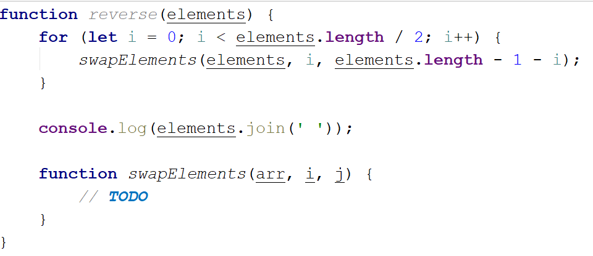

## Sum Even Numbers

Write a program which receives an **array** ofstrings**,** **parse** them to numbers and **sum** only the **even** numbers.

### Examples

|  |  |
| --- | --- |
| **Input** | **Output** |
| ['1','2','3','4','5','6'] | 12 |
| ['3','5','7','9'] | 0 |
| ['2','4','6','8','10'] | 30 |

### Hints

* Parse each string to number

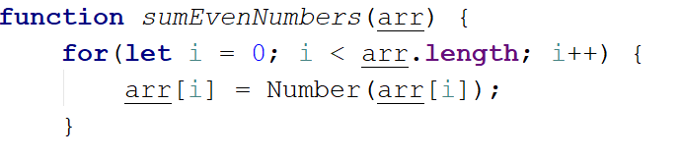

* Create a variable for the sum

wH1zbzT

* Iterate through all elements in the array with for-of loop
* Check if the number is **even**

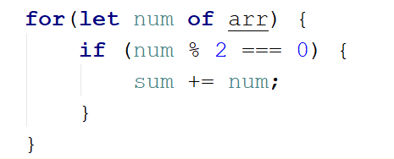

* Print the total sum

## Even and Odd Subtraction

Write a program that calculates the **difference** between the sum of the **even** and the sum of the **odd** numbers in an array.

function solve(numbers){  
  
  
  
  
 let evenSum=0;  
let odSum=0;  
  
 for(let number of numbers) {  
 if (number % 2 === 0) {  
  
 evenSum+=number;  
  
 }else{  
  
 odSum+=number;  
 }  
 }  
  
 ***console***.log(` Sum from even numbers : ${evenSum}`);  
 ***console***.log(` Sum from odd numbers :${odSum}`);  
  
  
  
 ***console***.log(` The difference between even and odd numbers :`, evenSum-odSum);  
  
  
}solve([1,2,3,4,5,6]);

### Examples

|  |  |  |
| --- | --- | --- |
| **Input** | **Output** | **Comments** |
| [1,2,3,4,5,6] | 3 | 2 + 4 + 6 = 12, 1 + 3 + 5 = 9, 12 - 9 = 3 |
| [3,5,7,9] | -24 |  |
| [2,4,6,8,10] | 30 |  |

### Hints

* Parse each string to number



* Create two variables - for **even** and **odd** sum

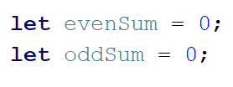

* Iterate through all elements in the array with for-ofloopand check if the number is odd or even

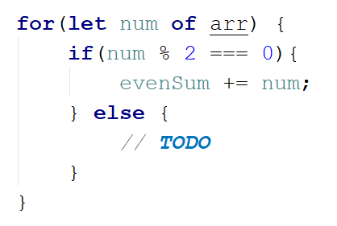

* Print the difference

## Equal Arrays

Write a program which receives **two** **string arrays** and print on the console whether they are **identical** or NOT.

Arrays are identical if their elements are **equal**. If the arrays are identical find the **sum** of the first one and print on the console following message:

'Arrays are identical. Sum: {sum}'

If the arrays are **NOT identical** find the **first index** where the arrays **differ** and print on the console following message:

'Arrays are not identical. Found difference at {index} index'.

### Examples

|  |  |
| --- | --- |
| **Input** | **Output** |
| ['10','20','30'], ['10','20','30'] | Arrays are identical. Sum: 60 |
| ['1','2','3','4','5'], ['1','2','4','4','5'] | Arrays are not identical. Found difference at 2 index |
| ['1'], ['10'] | Arrays are not identical. Found difference at 0 index |

### Hints

* First, we receive **two** arrays of strings and parse them.

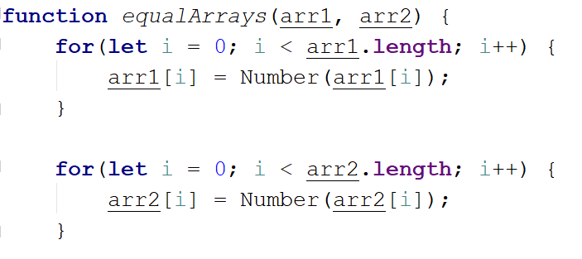

* Iterate through the arrays and **compare all element**. If the elements are **NOT equal** print the required message and break the loop.

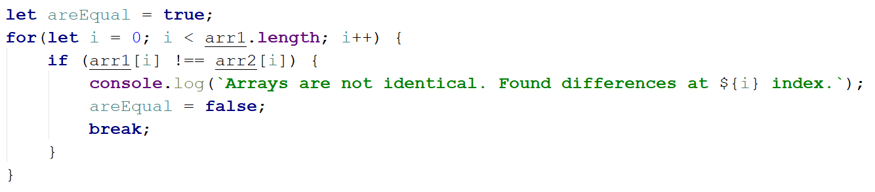

* Think about how to solve the other part of the problem.

## Condense Array to Number

Write a program which receives **an array of numbers** and **condense** them by **summing** adjacent couples of elements until a **single number** is obtained.

### Examples

For example, if we have 3 elements [2, 10, 3], we sum the first two and the second two elements and obtain **{2+10, 10+3} = {12, 13}**, then we sum again all adjacent elements and obtain **{12+13} = {25}.**

|  |  |  |
| --- | --- | --- |
| **Input** | **Output** | **Comments** |
| [2,10,3] | 25 | 2 10 3 🡪 2+10 10+3 🡪 12 13 🡪 12 + 13 🡪 25 |
| [5,0,4,1,2] | 35 | 5 0 4 1 2 🡪 5+0 0+4 4+1 1+2 🡪 5 4 5 3 🡪 5+4 4+5 5+3 🡪 9 9 8 🡪 9+9 9+8 🡪 18 17 🡪 18+17 🡪 35 |
| [1] | 1 | 1 is already condensed to number |

### Hints

While we have more than one element in the array nums[], repeat the following:

* Allocate a new array condensed[] of size nums.Length-1.
* Sum the numbers from nums[] to condensed[]:
  + condensed[i] = nums[i] + nums[i+1]
* nums[] = condensed[]

The process is illustrated below:

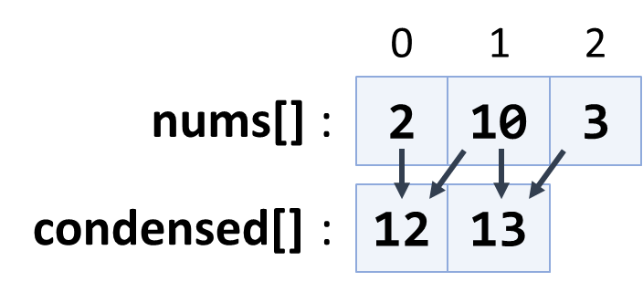 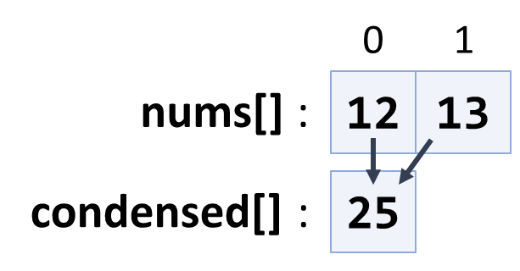

function solve(array){  
  
 let sum=0;  
  
 for(let i=0;i<array.length-1;i++){  
  
 sum+=***Number***(array[i]);  
 ***console***.log(sum);  
  
 }  
  
 for(let i=1;i<array.length;i++){  
  
 sum+=***Number***(array[i]);  
 ***console***.log(sum);  
  
 }  
  
  
}solve([2,10,3]);